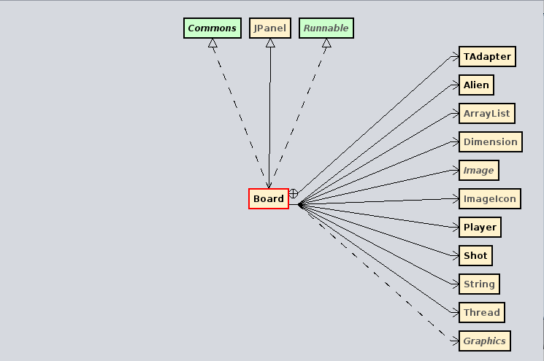

JPanel

Board
Fields
- ALIEN_INIT_X : int
- ALIEN_INIT_Y : int
- NUMBER_OF_ALIENS_TO_DESTROY : int
- aice : ImageIcon
- aliens : ArrayList<Alien>
- animator : Thread
- background : Image
- col : int
- d : Dimension
- deaths : int
- delay : int
- direction : int
«final»
- explImg : String
- ingame : boolean
- lastSlow : long
- level : int
- message : String
- ncubos : long
- player : Player
- pleyer : ImageIcon
- row : int
- score : int
- shot : Shot
- slow : boolean
- slowInterval : long
- ue : int
- vidas : int
Constructors
+ Board( ) : void
Methods
«synthetic»
~ access$0( Board ) : Player
«synthetic»
~ access$1( Board, boolean ) : void
«synthetic»
~ access$2( Board, long ) : void
«synthetic»
~ access$3( Board ) : boolean
«synthetic»
~ access$4( Board ) : Shot
«synthetic»
~ access$5( Board, Shot ) : void
«synthetic»
~ access$6( Board ) : long
«synthetic»
~ access$7( Board ) : long
«synthetic»
~ access$8( Board, int ) : void
«synthetic»
~ access$9( Board, long ) : void
+ addNotify( ) : void
+ animationCycle( ) : void
+ drawAliens( Graphics ) : void
+ drawBombing( Graphics ) : void
+ drawHeart( Graphics ) : void
+ drawIce( Graphics, int ) : void
+ drawPlayer( Graphics ) : void
+ drawShot( Graphics ) : void
+ gameInit( ) : void
+ gameOver( ) : void
- initBoard( ) : void
+ paintComponent( Graphics ) : void
+ run( ) : void
+ spawnAliens( ) : void
+ spawnHeart( ) : void

